Anstey Lane Traffic & Safety Issues

February 2016

A few thoughts alongside some photos we took over the period of just a week or two in early 2016...

1) Backing out of our driveway takes between 2-15 minutes each morning - we time it! So much traffic and so little patience or kindness, brought on by...
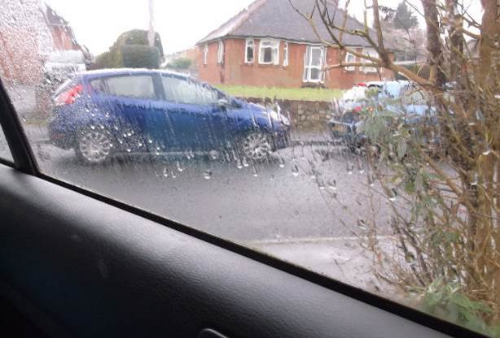
2) Legally yet dangerously parked cars that make it a nightmare to drive up the road - for cars and buses - and potentially lethal to cross the road. It is like a slalom run and the cars aren't always parked for long if they are Tesco’s customers, so it is constantly moving and changing, and car drivers in the morning become incredibly angry. Driving becomes less cautious, more risk-taking is evident and there is considerably less patience displayed, all of which result in a difficult Lane to navigate. My children have already been clipped and it is scary for us to back out onto, let alone drive down.
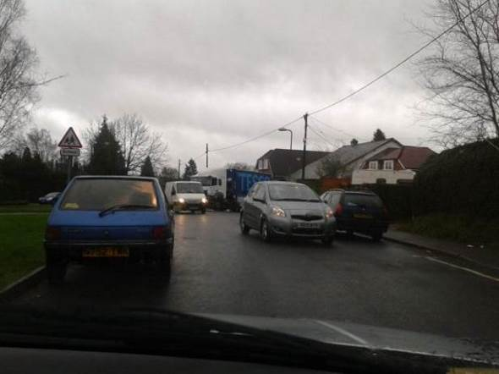
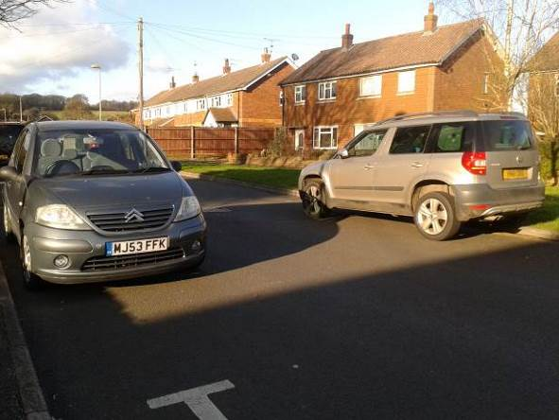
3) Huge delivery trucks park up directly outside the front door of Tesco’s Express and comes within inches of customers; turnings and manoeuvres are tight and the sight lines must be appalling for drivers, no matter how high up they are. This is a tough one to solve but it is evident that this jeopardises the safety of Anstey Lane residents and visitors.
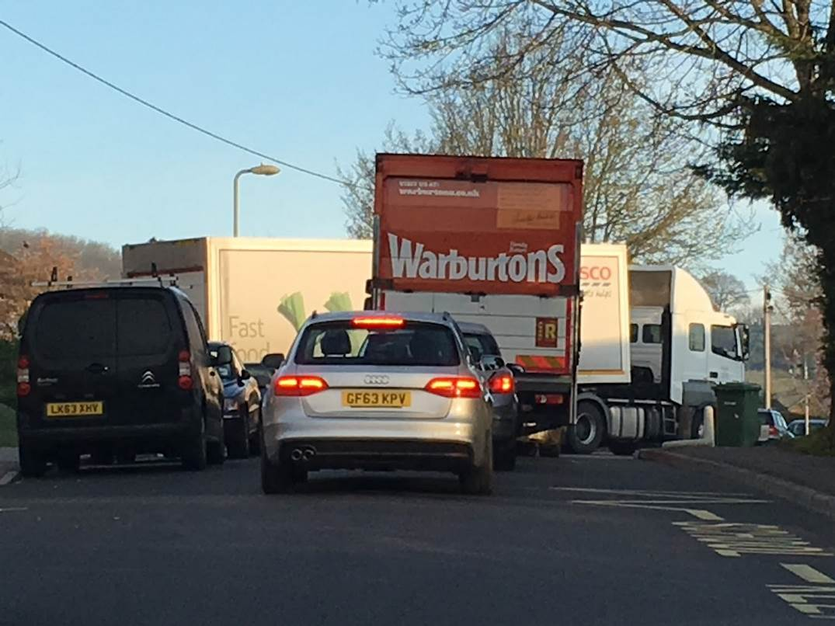
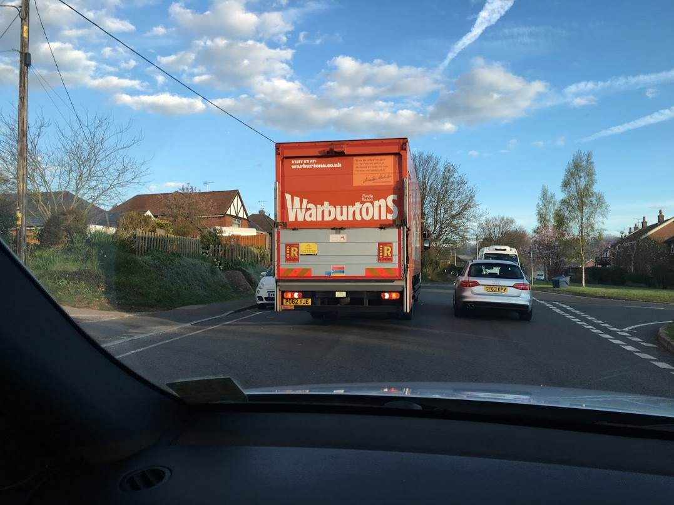
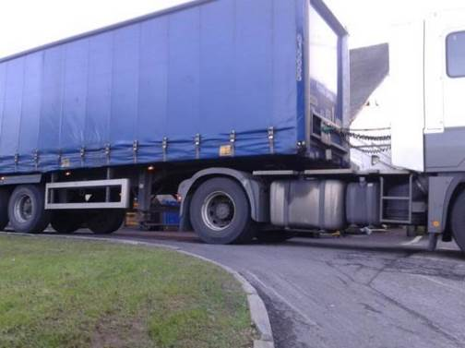
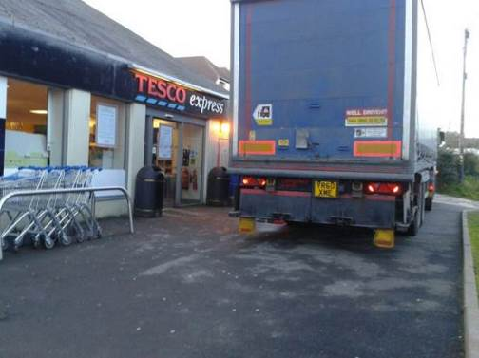

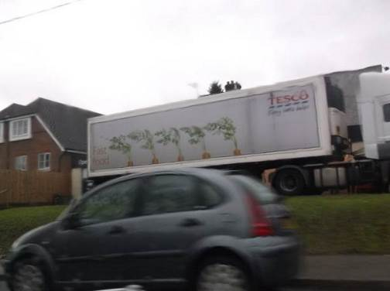

4) Tesco Express Shop customers drive at high speed up to the front door and park illegally right outside the front door. This happens daily (security bollards were implemented and apparently stolen) and we have seen many a knock, bump or very near miss in the few months we have lived here. Drivers are VERY angry if you ask them to move as the signage isn't clear and they feel they have every right to be there.
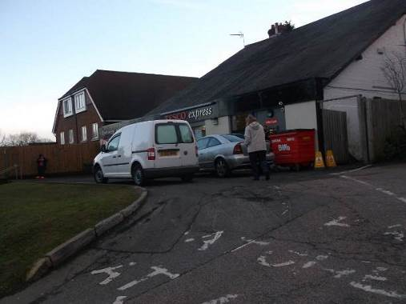

5) A lack of path alongside Anstey Park means kids, families, older people and all others are forced to cross near the entrance to Anstey Park
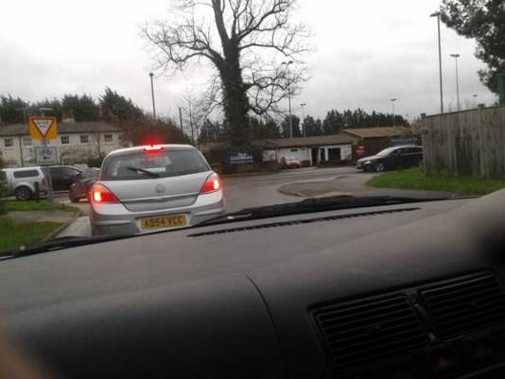
6) Sheer weight of traffic backed up Anstey Lane, forcing drivers onto much smaller roads with even less access, caused by...
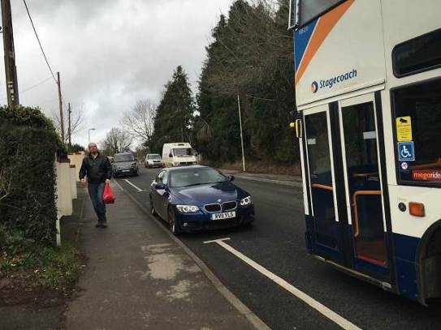
7) Standstill traffic along Anstey Road that makes it even harder to get out of Anstey Lane at peak times
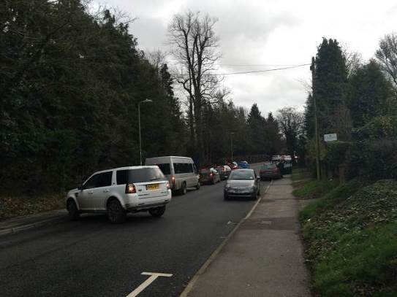
8) Large numbers of people using the clubs, fields and companies based on Anstey Park
